APPENDIX A TO NOTES TO TENDERERS

The Formula Approach to Tender Evaluation

(1) The Formula Approach for tender evaluation will take into account the forecast total of the Prices and the tenderer’s past performance under public works contracts. With respect to each conforming tender, a combined price and performance (overall) score will be worked out in accordance with the formula below. Normally, the tender with the highest overall score should be recommended for acceptance, subject to the usual requirement that the procuring department is satisfied that the recommended tenderer is fully capable (including technically, commercially and financially) of undertaking this contract, and that the recommended tender is the most advantageous to the Government in accordance with the tender provisions.
60 x | the lowest forecast total of the Prices among those conforming tenders
 | the forecast total of the Prices of the tenderer
+ 40 x | the tenderer’s performance score
 | the highest performance score among those conforming tenders
Forecast total of the Prices is subject to correction rules as stipulated in Clause GCT 11 of the General Conditions of Tender.

Conforming Tender
(2) For the purpose of calculation using the formulae above, a conforming tender means a tender which
(a) conforms to the essential requirements of the tender documentation; and
(b) is submitted by a tenderer which complies with the conditions of participation.
A conforming tender with abnormally low or high tendered total of the Prices or which is considered unsuitable for recommendation for the award of this contract (such as financially, commercially or technically incompetent) remains to be a conforming tender.

Performance Score
(3) The “performance score” in the above formulae will be worked out in accordance with the formulae below.
For cases where “training rating” is not applicable | Performance score = “performance rating” + “safety rating”
For cases where “training rating” is applicable | Performance score = “performance rating” + “safety rating” + “training rating”
(4) In case “training rating” is applicable, the full mark of the “performance score” will be increased from 110 (i.e. 100 for “performance rating” and 10 for “safety rating”) to 111 or 112 (with an addition of 1 or 2 mark for “training rating”).

(A) Performance rating
(5) The “performance rating” means the performance rating held in the DEVB’s Contractors’ Performance Index System (CMIS) on the original date set for the return of tenders or, if this has been extended, the extended date. The maximum rating in the CMIS is 100.
(6) If a tenderer has been enlisted by way of substitution, the performance rating of this tenderer as recorded in the CMIS will take into account the past performance of the previous contractor.
(7) If a tenderer does not have a rating on the particular date, it shall be assigned an average performance rating based on the performance ratings of the other tenderers who have submitted a conforming tender. In cases where the only conforming tenderer does not / all the conforming tenderers do not have any performance rating on the particular date, the tenderer(s) concerned will be given a performance rating of 50% of the maximum rating.

Joint venture
(8) The “performance rating” of a joint venture tenderer shall be evaluated as the higher of either –
(i) the weighted average of the performance ratings of the participants or shareholders in the joint venture in accordance with their percentage participation; or
(ii) the performance rating attained by the lead participant or major shareholder in the joint venture provided that the lead participant or major shareholder has a percentage participation of at least 70%; and that-
(I) all the other participants or shareholders are in the same Category as the lead participant or major shareholder and on the confirmed or probationary status of the same Group as the lead participant or major shareholder (where the lead participant or major shareholder is a confirmed contractor); or
(II) all the other participants or shareholders are in the same Category as the lead participant or major shareholder and on probationary status of the same Group or on confirmed status of a Group lower than that of lead participant or major shareholder (where the lead participant or major shareholder is a probationary contractor).
Where contractors not on the List of Approved Contractors for Public Works or contractors of more than one Category are invited to tender, only the method in (i) above is applicable in evaluation of performance rating of a joint venture tenderer.
(9) For the purpose of evaluation using the method in paragraph 8(i) above, where there is/are participant(s)/shareholder(s) in a joint venture who has/have no performance rating and there is only one participant/shareholder in this joint venture who has a performance rating, the performance rating of this joint venture tenderer shall be taken as the performance rating of the participant/shareholder who has a performance rating. Where there is/are participant(s)/shareholder(s) in a joint venture who has/have no performance rating and there are more than one participants/shareholders in this joint venture who have performance ratings, the performance rating of this joint venture tenderer shall be the weighted average of the performance ratings of the participants/shareholders who have performance ratings in accordance with their percentage participation. If none of the participants/shareholders in this joint venture has any performance rating, the performance rating of this joint venture tenderer shall be calculated in accordance with paragraph 7 above by considering this joint venture tenderer being a tenderer as described in that paragraph.

(B) Safety rating
Calculation of safety rating
(10) The “safety rating” is worked out from the past accident rates under public works contracts as per the accident and records of man-hours worked kept in DEVB’s PWP Construction Site Safety & Environmental Statistics (PCSES) for three 12-month periods fixed by reference to the original date set for the close of tender or, if this has been extended, the extended date, according to paragraphs 11 to 16 below.
(11) The three 12-month periods shall end on the last day of the calendar month immediately preceding the dates being 2 months (1st 12-month period), 14 months (2nd 12-month period) and 26 months (3rd 12-month period) respectively counting back from but excluding the original date set for the close of tender or, if this has been extended, the extended date. A table showing the three 12-month periods and measuring dates for tender closing dates is given below for illustration purpose.
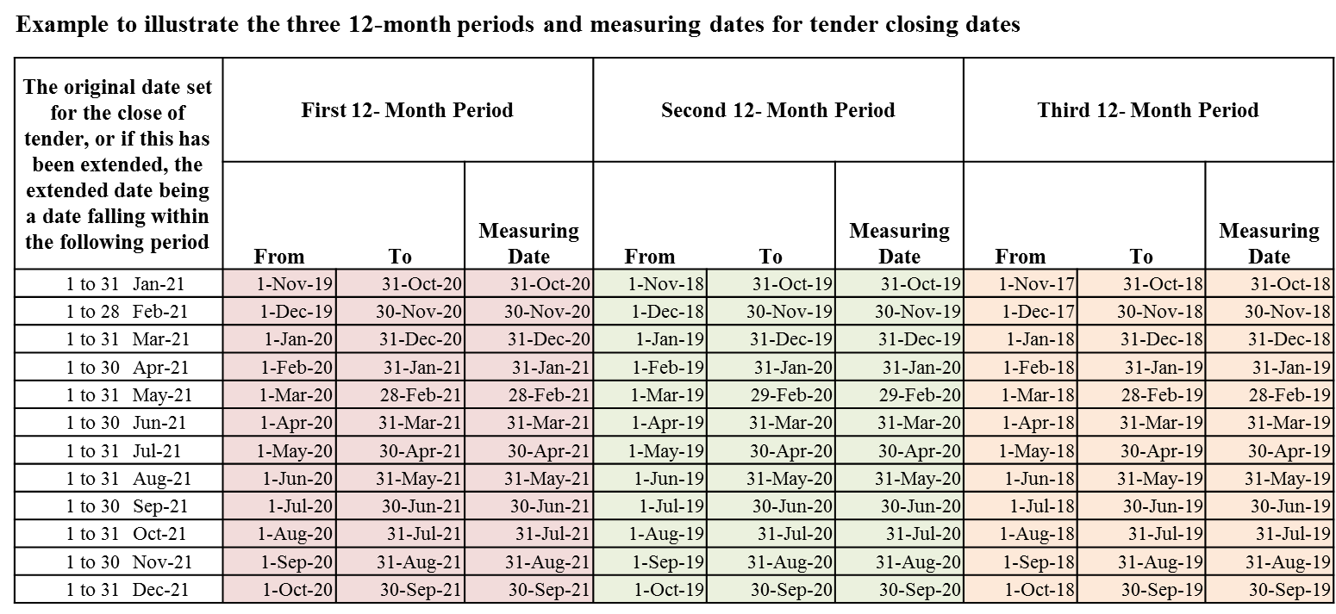
(12) The following formula shall be used for calculating the accident rates for the concerned 12-month periods:-
Accident Rate = | (No. of non-fatal reportable accidents¹ in the period) | + | (No. of fatal accidents in the period)
 | Total no. of man-hours worked in the period / 100,000 man-hours
¹ Reportable accidents mean those accidents resulting in an injury with incapacity for more than three days and all fatal accidents.
(13) For “safety rating”, the maximum total is 10 for the total of the three 12-month periods. The first, second and third 12-month periods have a maximum rating of 5, 3 and 2 respectively. Each tenderer’s safety rating is worked out by reference to the table below and shall be the sum of the three ratings corresponding to the three 12-month periods.
Tenderer’s Accident Rate@ | Rating
 | 1st  12-month | 2nd  12-month | 3rd  12-month
accident rate ≤ 25% of the limit # | 5 | 3 | 2
25% of the limit < accident rate ≤ 50% of the limit | 3.75 | 2.25 | 1.5
50% of the limit < accident rate ≤ 75% of the limit | 2.5 | 1.5 | 1
75% of the limit < accident rate ≤ 100% of the limit | 1.25 | 0.75 | 0.5
accident rate > 100% of the limit | 0 | 0 | 0
@ The unit of accident rate is number of accident per 100,000 man-hours worked.
# The limit of accident rate currently set by DEVB is 0.6.
(14) If a tenderer does not have an accident rate for a particular 12-month period (on the ground of no man-hour worked for that period), the accident rate to be used for that period shall be the average of accident rates for the other two periods. If a tenderer has an accident rate for one of the three 12-month periods only, that accident rate shall be used for calculating the safety rating for the other two 12-month periods.
(15) For a tenderer without any accident rate for the past three 12-month periods, its safety rating shall be the average safety rating attained by the other tenderers with a safety rating who have submitted a conforming tender.
(16) In cases where the only conforming tenderer does not/all the conforming tenderers do not have any accident rate for the past three 12-month periods, the tenderer(s) concerned will be given a safety rating of 50% of the maximum rating.

Joint venture
(17) The safety rating of a joint venture tenderer shall be the weighted average (in accordance with their percentage participation) of the safety ratings of the individual participants or shareholders which shall each be calculated in accordance with paragraphs 11 to 14 above.
(18) Where there is/are participant(s)/ shareholder(s) in a joint venture without any accident rate for the past three 12-month periods and there is only one participant/shareholder in this joint venture with accident rate(s) for the past three 12-month periods, the safety rating of this joint venture tenderer shall be the safety rating attained by the participant/shareholder in this joint venture with accident rate(s) for the past three 12-month periods. Where there is/are participant(s) / shareholder(s) in a joint venture without any accident rate for the past three 12-month periods and there are more than one participants/shareholders in this joint venture with accident rate(s) for the past three 12-month periods, the safety rating of this joint venture tenderer shall be the weighted average of the safety rating of the participants/shareholders in this joint venture with accident rate(s) for the past three 12-month periods in accordance with their percentage participation.
(19) If none of the participants/shareholders of a joint venture has any accident rate for the past three 12-month periods, the safety rating of this joint venture tenderer shall be calculated in accordance with paragraphs 15 - 16 above by considering this joint venture tenderer being a tenderer as described in those paragraphs.
(20) In calculating the accident rates of each participant/shareholder of a past/existing joint venture contract, the accident rates of the whole joint venture contract shall be used and attributed to the participant/shareholder irrespective of its share of the work in the past/existing joint venture contract.

Accident rates for tenders with or without involvement of Contractors of the Buildings Category
(21) For tenders invited from contractors of the Buildings category, the accident rates for completed and on-going contracts in the Buildings category only will be used in the calculation of the accident rates, hence the safety ratings for the assessment of tenders. For tenders invited from contractors from any category/categories other than the Buildings category, the accident rates for completed and on-going contracts in non-Buildings categories (i.e. all other categories) will be used. For tenders invited from contractors in more than one category including the Buildings category, the accident rates for all completed and on-going contracts in all categories will be used.

Obtain present value by discounting future payments
(22) For tenders with a forecast total of the Prices, if the tendered sums or the overall scores of the tenders under consideration with highest overall scores are very close (usually the three with the highest overall score), the procuring department should consider discounting future payments to obtain the present value and use the present value instead of the forecast total of the Prices in determining the ranking of the tenders. This calculation exercise should only apply to those conforming tenders with the highest overall scores (usually the top three).

[BLANK PAGE]

